
Development Request
Aria Systems
Material Purchase Order Header Report Customized

Custom program #: 102688
Customer: BRA14 - BRATEX

New Program Template Description

New Program Template

Material Purchase Order Header
Product: | Aria2.7
Module: | MA
Customer name: | Bratex (BRA14)
Installed Modules: | AL, AR, AS, AP, EB, CRM, GL, IC, MA, PDM, RM, SM, SO, SR, UP
Parameters setting: | They are set-up to use Extended Size Scale. They have GL linked to the system. They are setup to use Lot costing and keeping track of Rolls for MA module. They are also setup to use Dyelots for MA and IC (finished goods). They are also using Multi Currency.

System Setting Report:
We need to get a list of all system settings.
You can export the system settings through Aria 2.7 as follows:
Select the menu “User” then the Menu Option “Settings” then the submenu option “Export System Settings” then finally write down the file name to which settings will be saved.

Details Section
Report Name: Purchase Order Header
Report Objective: Need to modify the Selection Grid of this report to include new filter options that were created in the system. We will also modify the Layout of the report to include new information.

Existing Initial situation: Material Purchase Order Header Report

Description (Processing): We need to modify the Material Purchase Order Header report to include new options on the Selection Grid. These new fields will allow the user to filter by new customizations that were added to the Purchase Order Screen. These new fields are as follows: “MRP #”, and “Customer”. All these information will be available from the Purchase Order that was created in the system.
Selection Grid:

- “MRP# “ – This will be an “Inlist” field where the user will be able to browse by MRP #. If the user chooses to print by MRP# then all the Material Purchase Orders that are flagged with that MRP number will print in that Range. (MRP# will be an enhancement that will be done to the program that will give the user the ability to save an MRP “Requirement Report” at the time of printing. Aria will then give the user a sequential number for that save MRP. That MRP code will also be available for the Purchase Order Screen where PO’s created related to that MRP will be saved in the Purchase Order Header.) This will in turn give the user the flexibility to print by MRP# and all those Purchase Order in the system that have that MRP# will print in that Range
- “Customer” – The user will have the ability to filter PO’s created for Materials that are needed to supply a Sales Order for a Customer. On the Purchase Order they will assign a Customer account code and then they can filter this Report by that Customer Account Number
Report fields:
- “MRP#” – This field will print the MRP# that was saved with that Purchase Order in the system. This will print on the Header part of the Material Purchase Order Detail Report.
- “Customer” – This field will display the customer “Account Name” that the Material Purchase Order was created for. This also is coming from an enhancement that is being done on the Material Purchase Order Screen where the user can select an Account code in the system. This will also be located on the Header Part of the Material Purchase Order Detail Report
******NOTES

The information that are being displayed on this report is in conjunction with other customization that have been done to the system. The custom programs are as follows: “Vendor Material Reference”, Purchase Order Screen, Material Screen, Requirement Report.

Development Cost | $600
Customer signature
  Date signed
Payment Terms | 50 % due upon signing.  50% due upon delivery of the project.  (No work on this project will begin until the deposit is received)
Estimated completion time | 4 –6 weeks from signing and receipt of 50% of payment

Report Layout:
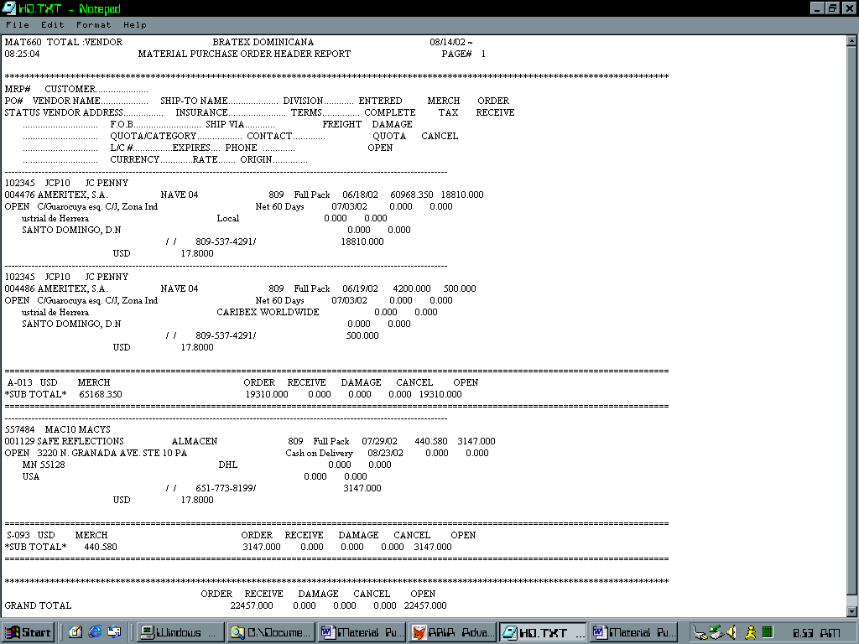
This is were we will place the MRP#
The Customer Account and Customer name will be here

